**AXIS Bank Banking Risk Analysis Dashboard**

**Problem Statement: -**

Develop a basic understanding of risk analytics in banking and financial services and understand how data is used to minimize the risk of losing money while lending customers.

**Solution: -**

With our dashboards which are created using Power BI latest tools helps the company to make a decision based on the applicant’s profile like if the applicant is likely to repay the loan, then approving the loan otherwise not.

**Case Scenario : -**

* Most defaulted loans are among "low-income" or "new relationship" customers.
* "Platinum" loyalty tier clients rarely default and maintain higher deposits.

A bank might then:

* Use this data to offer better loan terms to low-risk profiles and apply stricter checks (like credit score or additional collateral) for higher-risk groups.
* Monitor trends over time using year filters, noticing if certain segments become riskier due to economic changes.

**Problem : -**

**Client Segmentation and Targeting**

**Solution : -**

The dashboard enables detailed segmentation by banking relationship, income, nationality, and loyalty, making it easier to identify high-value groups and customize outreach or product offerings.​

**Problem : -**

**Performance Monitoring**

**Solution : -**

By visualizing key metrics for loans, deposits, fees, and product usage, the dashboard solves the problem of tracking financial health and business growth areas.​

**Problem : -**

**Retention and Loyalty Management**

**Solution : -**

Engagement length, loyalty classifications, and related fee analysis help the bank assess retention strategies and improve loyalty program effectiveness.

**Problem : -**

​**Profitability and Risk Assessment**

**Solution: -**

Breaking down deposits and loans by income and nationality uncovers sources of risk and profitability, enabling data-driven decisions on credit, investment, and marketing strategies.

**Problem : -**

​**Operational Efficiency**

**Solution : -**

Having centralized, quick access to comprehensive data (including drill-through options for deeper analysis) reduces time spent on manual reports and enables more agile management.​

**About Dataset –**

This dataset basically contains information about bank details, various client details which consists of multiple tables which are interlinked with each other through keys like primary key and foreign key.

The various tables are Banking Relationship, Client-Banking, Gender, Investment Advisor and Period.

**Data Cleaning –**

Creating bins for the Estimated Income < 100000 as low and <300000 as Mid with the column named as Income Band in Clients-Banking table.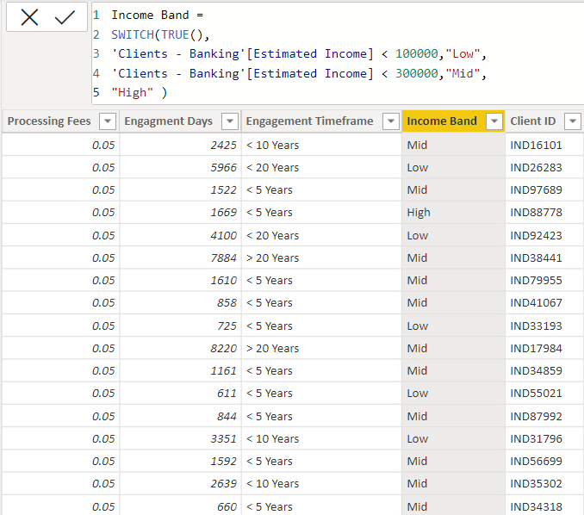

Creating a new column Engagement Days in Client-Banking table how many days the client spent from the date of joining in banks

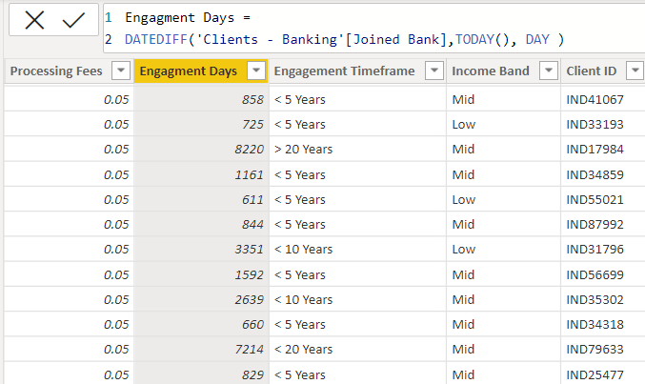

Creating a new column Engagement Timeframe in client-banking column which tells about the time line of the clients in banks

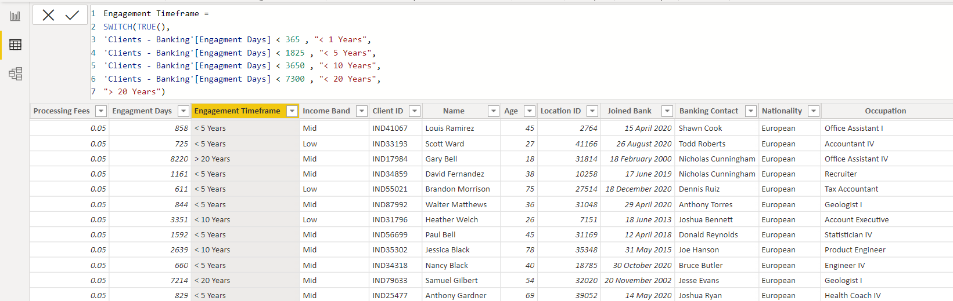

Creating a new column named as Processing Fees for the column Fee Structure like if fee structure is high then processing fee would be 0.05

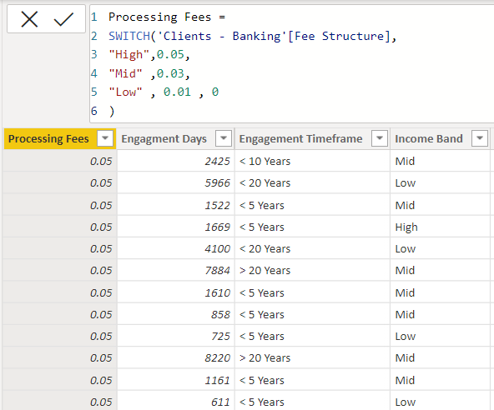

**Calculated Functions –**

**Sum:** The power bi sum function will add all the numbers in a column and the column contains numbers to sum. It returns a decimal number.

Bank Deposit =

SUM('Clients - Banking'[Bank Deposits] )

**Distinct Count :** Counts the number of distinct values in a column

Total Fees = SUMX('Clients - Banking' , [Total Loan] * 'Clients - Banking'[Processing Fees] )

**Switch :** Evaluated an expression against a list of values and returns one of multiple possible result expressions

SWITCH(<expression>, <value>, <result>[, <value>, <result>]…[, <else>])

**DATEDIFF :** Returns the number of interval boundaries between two dates.

Engagement Days = DATEDIFF('Clients - Banking'[Joined Bank],TODAY(), DAY )

**KPI’S:**

In which followings KPIS are present:

**Total Clients :** Total Clients KPI represents total number of clients in banking.

Total Clients = DISTINCTCOUNT('Clients - Banking'[Client ID] )

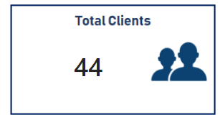

**Total Loan :** Total Loan gives you information about the bank loan + Business lending + credit cards balance of particular investor , gender.

Total Loan = [Bank Loan] + [Business Lending] + [Credit Cards Balance]

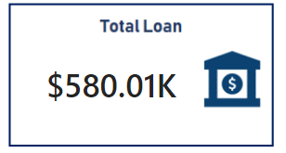

**Bank Loan :** Bank Loan gives you information what is the loan amount of loan to be repaid by the client to bank.

Bank Loan = SUM('Clients - Banking'[Bank Loans] )

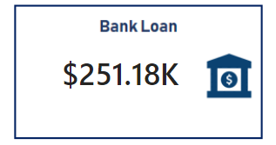

**Business Lending :** Business lending gives you information about the loan amount given to small business.

Business Lending = SUM('Clients - Banking'[Business Lending] )

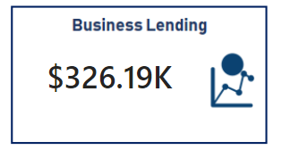

**Total Deposit :** Total Deposit gives you information about the amount deposited by particular investors in bank

Total Deposit = [Bank Deposit] + [Savings Account] + [Foreign Currency Account] + [Checking Accounts]

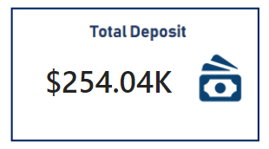

**Total Fees :** Total Fees is nothing but the amount charged by the bank for account set-up , maintenance charges etc.

Total Fees = SUMX('Clients - Banking' , [Total Loan] * 'Clients - Banking'[Processing Fees] )

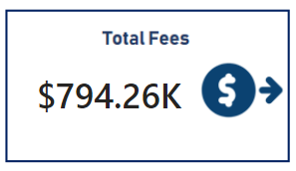

**Bank Deposit :** Bank deposit is the money put in the bank.

Bank Deposit =

SUM('Clients - Banking'[Bank Deposits] )

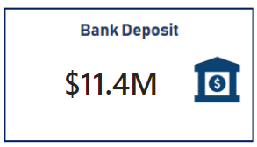

**Checking Account Amount :** Checking account amount is nothing but which offers easy access to your money for daily transactional needs.

Checking Accounts =

SUM('Clients - Banking'[Checking Accounts] )

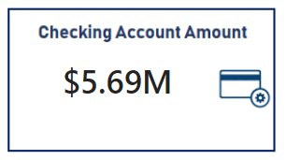

**Total CC Amount :** Total CC Amount is a short-term source of financing for a company by a bank.

Total CC Amount = SUM('Clients - Banking'[Amount of Credit Cards] )

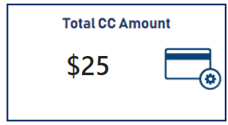

**Saving Account Amount :** A savings account is an interest-bearing deposit account held at a bank.

Savings Account = SUM('Clients - Banking'[Saving Accounts] )

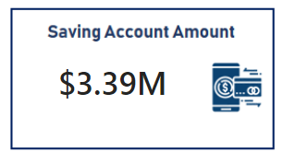

**Foreign Currency Amount :** Foreign Currency Account means an account held in a currency that is not the currency of India or Bhutan or Nepal.

Foreign Currency Account =

SUM('Clients - Banking'[Foreign Currency Account] )

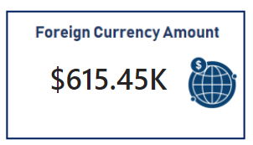

**Engagement Account :** Engagement Banking is nothing but puts the customer at the centre and aims to deliver the digital experiences they expect.

Engagement Length =

SUM('Clients - Banking'[Engagment Days])

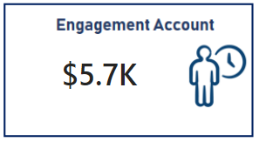

**Credit Cards Balance :** It is the total amount of money currently owned by a cardholder to their credit card bank.

Credit Cards Balance = SUM('Clients - Banking'[Credit Card Balance] )

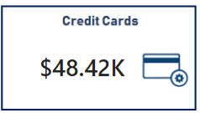

**Conclusion –**

Empowered by the latest data visualization techniques, Power BI dashboards are among the most effective resources for using in banking sector. As outlined in this write-up, a banking operations dashboard in Power BI can be developed with key banking related metrics and KPIs.

**Future Work –**

With these dashboards banks can easily know what is the total loan amount and all other things of a particular investor.

It also helps which type of banks have more number of clients as we can see private banks have more number of clients so it can helps other banks can build their strategies to increase clients.

It also provides insights about which nationality has highest bank loans.

It gives information about various types of amounts involved in different types of accounts by investors.

**Summary**

This dashboard allows Axis Bank to monitor overall performance, analyse customer segments, optimize product offerings, and improve retention and profitability by turning complex banking data into actionable insights